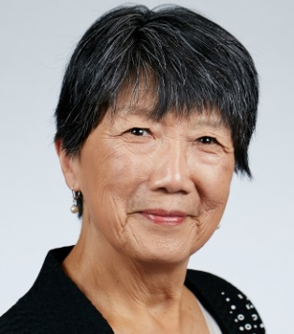
CAROL A DUANE
2020 CANDIDATE FOR ACS PRESIDENT-ELECT
Dear Members of the Division of Chemical Health and Safety:
Thank you for the opportunity to tell you my view of the optimal interaction between the Division of Chemical Health & Safety and the office of the President-elect of the Society could be. As I mentioned when I spoke to the CHAS Executive Committee in San Diego, I had always felt that safety and health are integral elements of chemistry and that appropriate awareness and care are inherent in being a professional. The concepts of risk and safety were instilled by my very first chemistry teacher and reinforced in the culture of every laboratory and career role I experienced. Speaking with many of you who are ‘boots on the ground’ in the current environment has made me realize that my experience is not universal and is perhaps unique. That may be because my experiences were colored strongly by the fact that both my parents and my husband were and are highly professional chemists.
The key elements of my platform for the role of President of ACS which I feel is the global voice for chemistry – the science, the industry, and you the practitioners are empowering chemists to lead, forging powerful industry collaborations, and building a strategic future for the enterprise. This is an opportune time for ACS to enhance our value as the recognized authority for our science, our enterprise, and our professionals. Ensuring that our core values, particularly Safety are instilled, nurtured and flourish will advance the broader chemistry enterprise and its practitioners for the benefit of Earth and its people. As president -elect, what would I do to make this happen?
Hear and Support
As leaders and active champions for chemical safety and professionalism, CHAS and CCS are best positioned to understand the climate and culture of Safety in the chemistry enterprise, recognize gaps in the resources and mentoring that ACS provides, and raise awareness of situations to address. As President-elect, I will be listening to what you recommend and looking to see how we can leverage our successful established Safety programs to create more opportunities to advance the prominence of Chemical Health and Safety matters.
Collaborate
Corporations in the chemistry business world excel at actualizing the potential of research ideas and converting them to practical uses. As collaborative advocates, they could proactively incorporate safety and health as key elements as they develop chemistry solutions for the world’s major issues. As President-elect, I would work with you to identify prospective partners to develop collaborations to join our voices to emphasize the inherent value of built in safety and health safeguards.
Strategic Approach
Finding a strategic purpose and developing innovative strategies is key to successfully achieving successful outcomes and impact. Part of the process means making tough choices on where to focus resources and attention in a timeframe. As President-elect, I would support you as you prioritize and implement programs that achieve your portfolio of objectives so that significant progress will energize the progress.
Giving back
Our contributions as ACS professionals and volunteers can make a difference. Now is a great time to take bold, ambitious steps to improve people’s lives. With empowered and engaged professionals and the problem-solving duo of chemists and enterprise leaders, we have the wherewithal. We can step up and be the world’s big voice in creating awareness of global issues and spearheading efforts to attack them. As ACS president, I would like to lead you in these endeavors. If these ideas resonate with you, please vote for me and ask others to do so.
Visit my website for details on my qualifications and accomplishments: https://caroladuane.com.

