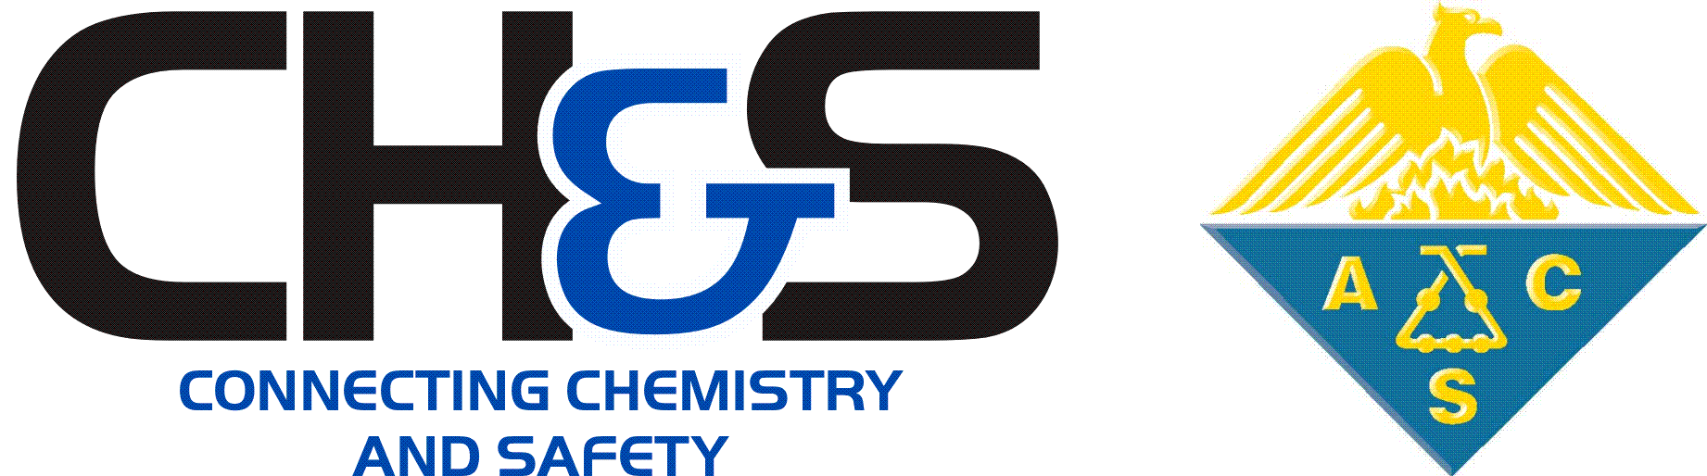 | CHAS Lifetime Achievement Award

Award Nomination Application

Please read the CHAS Awards Nomination Guidelines before Completing this Form

Nominee Information
Nominee’s Full Name (Primary Contact): |  |  |  | Date:
 | Last | First | M.I.

Nominee’s Phone Number: |  | Nominee’s Email:

Nominee’s Title/Position: |  | Nominee’s Company or Institution Name:

Nominee’s Organization or Department:

Nominator Information
Check this box if this is a self-nomination. The contact information above will be used.
Otherwise, provide the contact information for the nominator below.

Nominator Full Name: |  |  |  |  |  |  | Date:
 | Last |  | First |  |  | M.I.
Nominator Phone Number: |  |  |  | Nominator Email:

Check this box if you want to recommend only that the CHAS Awards Committee should contact the nominee named above to suggest they self-nominate for this award.

In this case, the CHAS Awards committee may elect to contact the suggested person or team to recommend that they submit a complete self-nomination application. We do not guarantee that we will contact every nominee suggested to us.

If you selected this option, your application form is finished. You can email it to Awards@dchas.org without completing the remaining sections.

To provide a complete nomination for consideration by the Selection Committee, please continue by filling out all pages of this application.

Cover Letter
Cover Letter (750 words or fewer) | Describe why the nominee’s accomplishments are deserving of this award. The letter should describe the nominee’s work and how it is aligned with the purpose, eligibility, and/or criteria of the award, the impact on the discipline, the significance of this effort, and the benefits to the Society and/or Division. Consider in the letter how the awardee has shown support for the goals and activities of CHAS, the ACS, and the chemical health and safety community; and how the nominee has, through personal effort, helped CHAS and the ACS reach those goals.

Click here if you are attaching a cover letter as a separate file. Otherwise, please type or paste your cover letter into the space below.

Cover letter attachments must be named as follows: “[Award Year] [Nominee LAST Name] CHAS Lifetime Achievement Award Cover Letter”. (e.g. 2020 Smith Lifetime Achievement Award Cover Letter.pdf).

Acceptable file formats are .docx, .pages, or .pdf

If you’re not attaching a separate file, type or paste the body of the cover letter as plain text below (750 words or fewer). Omit greetings and closings.

Biographical Sketch
Biographical Sketch | This is a brief (1 paragraph) description of the nominee and their accomplishments as they relate to the chemical enterprise, chemical health and safety, and the award criteria. For example, this information might be used to introduce an awardee when presenting the award to them at the annual awards symposium.
Type or paste the biographical sketch as plain text below.

Publications and Patents (if applicable)
Publications and Patents (if applicable) | If applicable, list citations for any publications or patents that have significance to the general area of the award’s purpose. You do not need to attach the full text. The Selection Committee will request more information if needed.
Type or paste the list of citations below or leave blank if non-applicable. (plain text only)

Additional Supporting Information
Additional Letters of Support (400 words or fewer, optional) | If desired, additional letters of support may be included with the nomination application. Support letter writers are not required to be members of the Society or the Division of Chemical Health and Safety. The Supporter’s contact information must be included in the letter. Support letters should contain information not already addressed in the cover letter. The support letter should clearly describe the impact of the nominee’s work and the ways in which they have met the purpose and criteria of the award.
 | Click here if you are attaching (optional) additional letters of support as separate files.
Support letter attachments must be named as follows:
“[Award Year] [Nominee LAST Name] [Initials of Support Letter Author] Lifetime Achievement Award Support Letter”. (e.g. 2020 Smith KB Lifetime Achievement Award Support Letter.pdf).

Acceptable file formats are .docx, .pages, or .pdf

Code of Conduct Confirmation
By checking this box, I certify that my responses are true and complete to the best of my knowledge, and that to the best of my knowledge, including past and present circumstances, the nominee adheres to the standards of the ACS’s Chemical Professional’s Code of Conduct. To the best of my knowledge, the nominee:
- Employs and requires good safety protocols in his or her laboratory and/or work environment.
- Upholds the highest ethical standards in his or her laboratory and/or work environment.
- Otherwise engages in conduct that is consistent with both the objects of the American Chemical Society as stated in Article II, Section 1 of Constitution and the Chemical Professional Code of Conduct.
If you have any concerns about this nominee’s eligibility based on ethics or conduct, please contact the CHAS Awards Chair to discuss these issues (awards@dchas.org).

Submit Completed Nomination Application

- Confirm that you have completed all pages of the nomination form.

- Confirm that you have properly named the files for all required and optional attachments as instructed above.

- Send your completed application by email to the CHAS Awards Committee Chair at Awards@dchas.org.

Name this application file: [Award Year] [Nominee LAST Name] CHAS Lifetime Achievement Award Application
(e.g. 2020 Smith CHAS Lifetime Achievement Award Application.docx). DO NOT CONVERT THIS FILE TO A PDF

Attach this form and all other supporting files to the email message.

- You should receive a confirmation message from the CHAS Awards Committee Chair that your application was received. If you do not receive a confirmation within 7 business days, please inquire.

