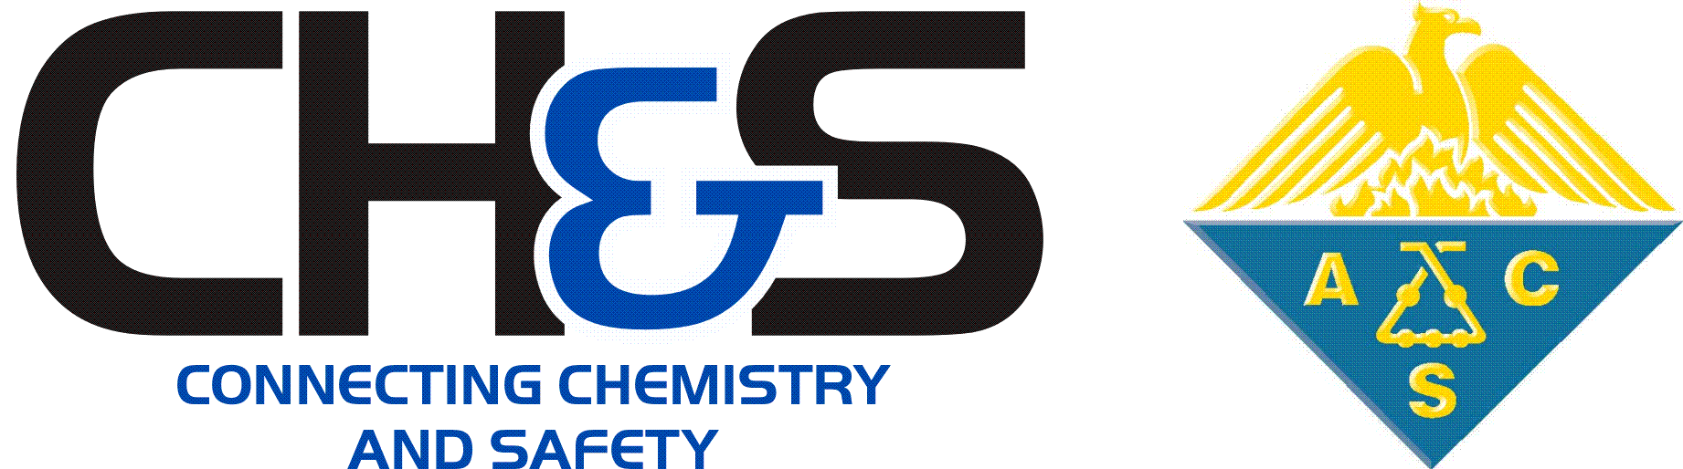 | CHAS Student Registration Award Application

Award Application
This form may only be used to request reimbursement in the amount of full conference registration fee (undergraduate, graduate, or pre-college teacher student rate, as applicable) for students presenting in CHAS symposium or poster session at an ACS national meeting.

Applicant Information
Applicant’s Full Name (Primary Contact): |  |  |  | Date:
 | Last | First | M.I.

Applicant’s Phone Number: |  | Applicant’s Email:

Applicant’s Title/Position: |  | Applicant’s Institution Name:

Applicant’s Organization or Department:

Presentation Information

Presenting at which national meeting? |  |  |  |  |  | Meeting registration type:
 |  | Fall | Year: |  |  |  | Pre-College Teacher
 |  | Spring | Year: |  |  |  | Graduate Student
 |  |  |  |  |  |  | Undergraduate Student

Type of Presentation:

Oral Presentation
Poster

Name of Presentation or Poster
(Use a “working title” if necessary”):

Name of CHAS symposium or poster session (if known):

Abstract number (if known):

Code of Conduct Confirmation
By checking this box, I certify that my responses are true and complete to the best of my knowledge, and that to the best of my knowledge, including past and present circumstances, the applicant adheres to the standards of the ACS’s Chemical Professional’s Code of Conduct.

Submit Completed Application

- Confirm that you have completed all pages of the application form.

- Send your completed application by email to the CHAS Awards Committee Chair at Awards@dchas.org.

Name this application file: [Award Year] Student Registration Award [Nominee LAST Name] Application
(e.g. 2020 Student Registration Award Smith Application.docx). DO NOT CONVERT THIS FILE TO A PDF

- Student Registration Awards are granted on a first-come, first-served basis for eligible applicants.

  - If you are eligible, and there is an available award for the requested meeting, the CHAS Awards Committee Chair will notify you immediately and provide instructions on how to submit your registration receipt to CHAS for reimbursement.
  - If you are ineligible or if there are no more awards available for the requested meeting, the CHAS Awards Committee Chair will notify you immediately.

- You should receive a confirmation message from the CHAS Awards Committee Chair that your application was received. If you do not receive a confirmation within 7 business days, please inquire.

